Aja Illicium griffithii Management & Marketing Plan
(2nd Revision)
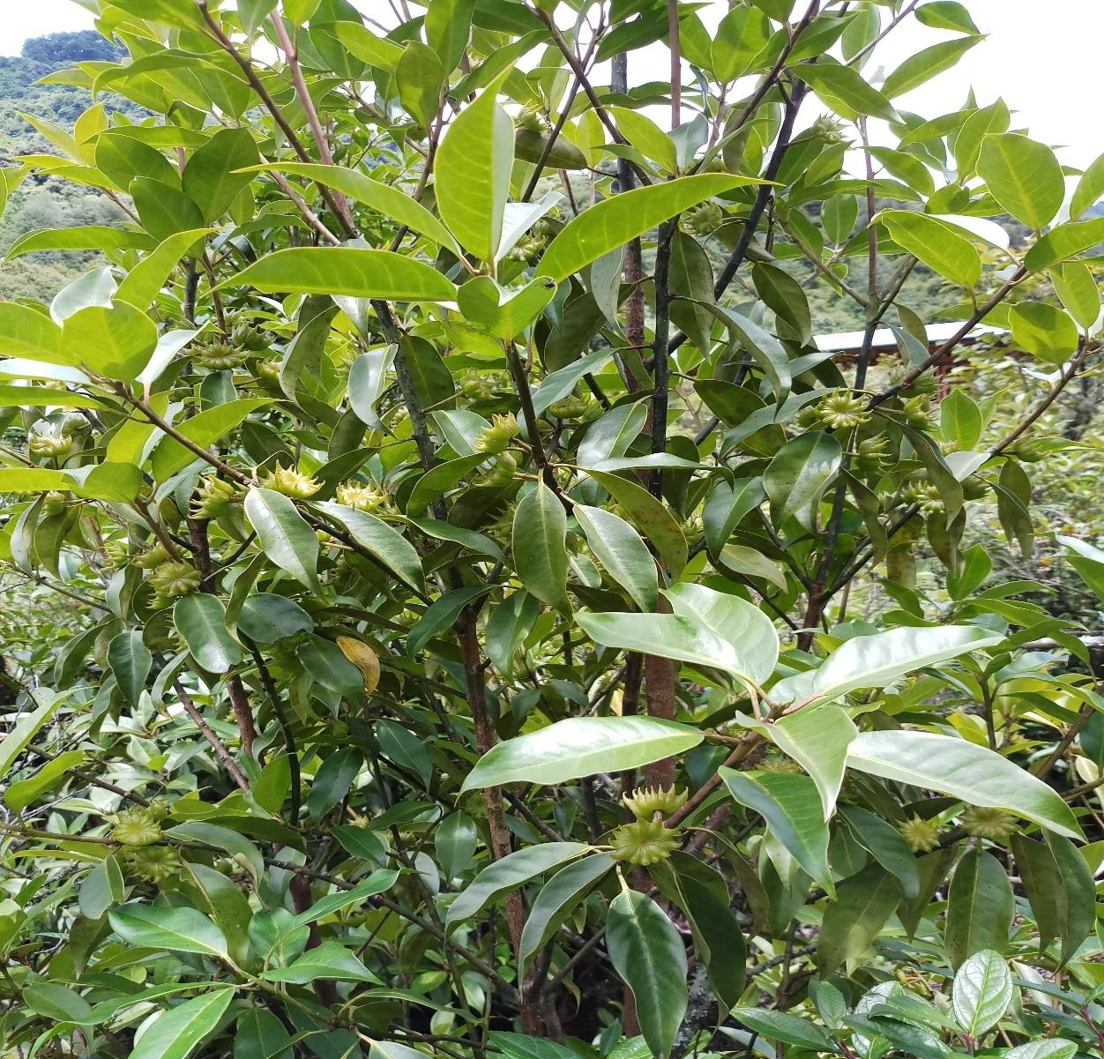

Shelrimuhung Gewog
Mongar Dzongkhag

Plan Period: 2025 – 2035

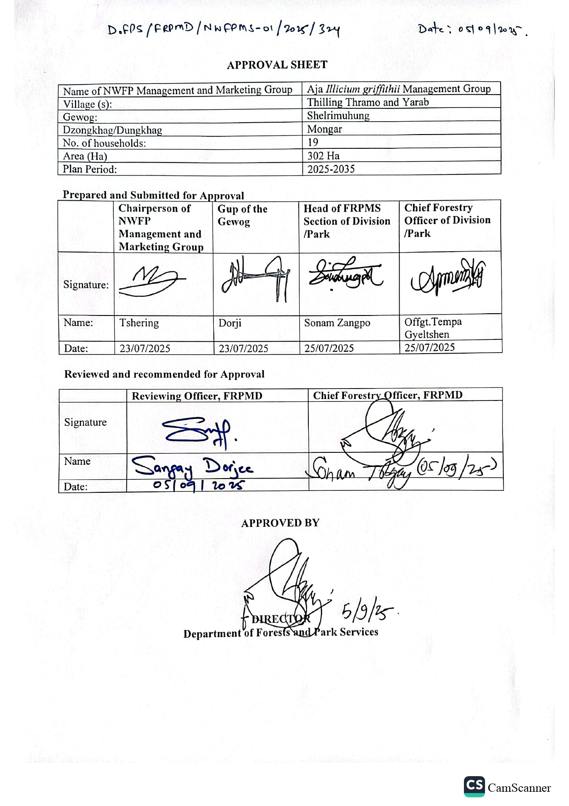

Contents
PART A: NWFP MANAGEMENT AND MARKETING PLAN 1
1. Background 1
2. Objectives: 1
3. Description of NWFP 2
3.1 Conservation Status of Illicium griffithii 3
4. Harvesting prescriptions for sustainable NWFP harvesting 3
5. Marketing and sales plan 4
6. Marketing arrangement 4
7. Benefit to the members 4
8. Benefits to the group 5
9. Resource assessment and results 6
PART B: GROUP BY-LAWS 8
10. NWFP management & marketing group 8
10.1 Membership arrangement and resignation 8
10.1.1 New membership 8
10.1.2 Withdrawal of members 8
10.2 Responsibilities and rights of members 8
11. Executive committee of the NWFP management and marketing group 9
11.1 Chairperson 9
11.3 Treasurer 9
12. Tenure of committee members 10
13. Incentives to the committee members 10
14. Source for the generation of the group fund 10
14.1 Membership registration fees/annual contribution 10
14.2 Collection from the sale of proceeds 10
15. Group fund management and utilization 10
16. Conflict management 11
17. Meeting and Purpose 11
17.1 Committee meeting: 11
17.2 General Meeting 11
18. Penalties 11
19. Roles and authority of the Department 11
ANNEXURE I: Application i
ANNEXURE II: Group Members ii
ANNEXURE III: Harvesting Sites vii
ANNEXURE IV: Coordinates for the Management Area vii
ANNEXURE V: Pictorial Evidence viii

PART A: NWFP MANAGEMENT AND MARKETING PLAN

1. Background
The Aja Illicium griffithii management group falls within the multiple-use zone of Bumdeling Wildlife Sanctuary, towards the North-East of Shelrimuhung Gewog, Mongar Dzongkhag. The Illicium griffithii management group comprises 19 households from three villages in Yarab under Soenakhar chiwog, as well as Thramo and Thilling of Jabgang Chiwog. The livestock and agricultural practices were a major source of income for livelihood. Besides other forestry products, such as Elatostema spp, Diplazium spp, and the shoot of Plectocomia himalayana for minimal cash income. Most household practices semi-nomadic lifestyles where they practice seasonal migration between Aja and their settlement.
The collection of Illicium griffithii has been an age-old practice used locally for various purposes, such as flavoring tea, increasing the strength of Ara, and curing coughs and toothaches. The community first started to collect the fruits of I.griffithii in the 1990s became customary right over the collection. Therefore, the community felt that it is imperative to continue with the management group and legalize the rights of resources used and harvesting, and keep the ownership intact with them; otherwise, due to the increase in visitors visiting the sacred sites, and face the risk of overexploitation of the resource and leading to the unsustainability of the resources.
Currently, managing Illicium griffithii and marketing does not have a substantial cash inflow to the group; however, it has potential for marketing through value addition and packaging, which will be the source of additional cash for the group. Therefore, the management of Bumdeling Wildlife Sanctuary has facilitated in revision of their management plan. The group encompasses the total area of 302 hectares for managing the resources, including some portion of the area under natural grazing ground based on their traditional management system. The main forest cover is cool broad-leaved forest with under-story vegetation of Rhododendron and Gaultheria species.
Review of past management plans
The legalized management of Illicium griffithii (Sangpasay) commenced in 2008 as a Community Forest Management Group and completed 10 years of management. During the 1st revision of the plan, in consultation with the group member, streamlined the resources management solely to the Illicium griffithii and revised as NWFP group under the legal provision of Forest and Nature Conservation Rules and Regulation, 2017 and managed for three years however, with the amendment of FNCRR 2017 in 2020 the management tenure was extended for another two years till 2024.
So far, the group has generated a sum of Nu. 76555.37 despite facing marketing challenges, transportation of the product from the collection site, as it is far-flung from the settlement.
- Year 2008 – 2020, the group has generated a total revenue of Nu. 30,622/-
- Year 2020-2025, the group has generated Nu. 45,933.37/-

2. Objectives:
- For the sustainable management (manage and collect the Illicium fruits/seedpods) of Illicium griffithii, including the encouragement of age-old traditional rights
- To stimulate the income generation of the local communities through the sale of NWFP products
- To provide job opportunities to the local communities
- To provide a sense of ownership
The main tasks of the NWFP Management Group will be the sustainable collection of seed pods/fruit at the right time and monitoring the NWFP area from illegal activities. The communities still hope that the management of star anise would bring some additional cash income for their socio-economic development with the establishment of the Aja Community-Based Ecotourism Management Group.

3. Description of NWFP
Illicium griffithii is an evergreen medium-sized tree that grows at an elevation from 1800 to 2800 masl. The tree can reach up to 30m in height. The flowering takes place from January to April, while fruiting begins from the end of April. Trees of at least three to four years old with a diameter of 2-3cm can start to bear fruit. The star-shaped fruits start maturing from September onwards. In general, it bears fruit once a year in alternating cycles of one good productive year followed by a year of poor production. However, hailstorms during the flowering season have a very detrimental effect and can upset the entire production cycle. I.griffithii grows well in a loamy soil, in evergreen oak forests, and is a light-demanding species. I. griffithii trees respond well to a coppicing system, and production of coppiced trees is higher.

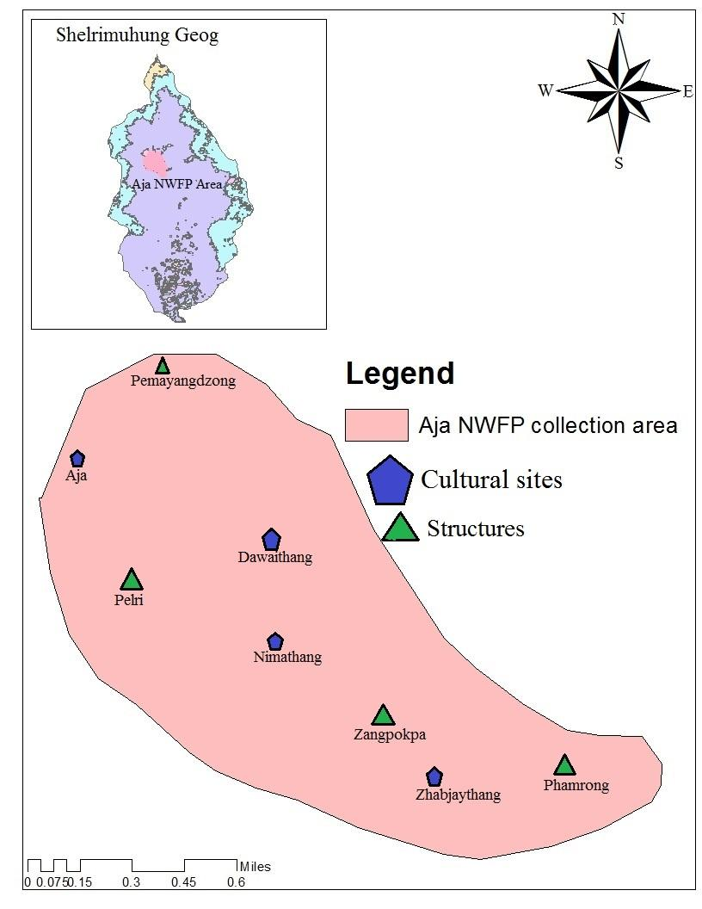
Figure 1. Map of the Aja NWFP group
- Area boundaries by indicating well-known existing features (house, road, trails, chortens, streams, ridges, etc.)
- Harvesting areas by local names
- Estimated size of the harvesting areas: 302 hectares
- Estimated quantity of NWFP that can be collected per harvesting area: 150 kgs
- Walking distance to the harvesting areas: 1-day walk

3.1 Conservation Status of Illicium griffithii
- IUCN Red Lists: Endangered (EN)
- FNCA 2023: Schedule III
- Threatened medicinal plant native to the Eastern Himalayas
Table 1. Brief description of NWFPs for commercial harvesting in each season
NWFP Name | Harvesting area(s)  name) | Parts harvested | Use purpose (traditional & others) | Harvesting season (months) | Estimated quantity for harvest in a season/ year
Illicium griffithii  Star anise | Bakthroe, Duthrue | Seed Pods/ fruits | Medicine, Incense, flavoring tea, etc. | 8th to 10th month of the Bhutanese calendar (October – December) | 150 kgs annually for commercial marketing
 | Langchengang
 | Dungjur, Menchu
 | Pemayangdzong
 | Sherizampa Ko
 | Dawathang
 | Nimathang
 | Zangpokpa
 | Zhabjaythang
 | Phamrong, Tshaney
 | Awachu Jug
 | Draangney
 | Samtenling

4. Harvesting prescriptions for sustainable NWFP harvesting
The objective of forming the NWFP management group for star anise is to manage and collect Illicium fruits/seed pods on a sustainable basis, following the guidelines outlined in 'Guidelines for Resource Assessment and Management of I.griffithii June 2008.
Table 2.Harvesting prescriptions for sustainable NWFP harvesting
NWFP species | Harvesting prescriptions for sustainable harvesting
Illicium griffithii  (Sengpasay) | - Seed pods shall be collected from the forest floor by hand-picking  - Harvesting will be done when the seeds are mature  - The trees should not be felled for seed pod collection  - The seed pods should be collected from the forest floor before they turn blackish, as it is said to be of inferior quality  - All seed pods can be collected from the forest floor, as many seeds are dispersed when the seed pods are still on the tree, which cannot interfere with the natural regeneration of the species  - For ecological reasons, it is recommended to collect seed pods at the end of October to December, when the seed pods have released all their seeds, if it is to be plucked directly from the branches

5. Marketing and sales plan
The marketing and sale of star anise will be organized in groups by the committee members of the NWFP group in collaboration with DoFPS and NWFP dealers. The committee members of Star Anise Management Group shall explore the potential market within Bhutan. The seed pods shall be weighed before drying and as well as after drying. The dried seed pods shall be handed over to the committee members for marketing and sale. To share resources and income equally among the group members, it is decided to work in a group, which also enables them to generate more income for the community development fund. As experienced in the past, they found that this system of marketing will provide transparency and trust among the group members.

Table 3. Marketing and sales plan of the group
NWFP | Potential market | Estimated quantity  for sale/season (unit) | Expected price per unit | Total (Nu)
Illicium griffithii  (Sengpasay) | Within Bhutan (NWFP dealers, NITM) | 150 kg | Nu. 200.00 per kg | 30000.00

6. Marketing arrangement
The committee members, led by the chairperson of the group, shall seek potential markets within the country, as the produce is typically exported by certified NWFP dealers. All the group members shall collect seed pods for two times (seed pod harvesting and seed pod collection) during the prescribed harvesting season based on the fruiting of star anise. The collected seed pods are then handed over to the committee members at Doleptang/Yarab road point for sale. Moreover, the NWFP group members should initiate and encourage the packaging of star anise in different quantities for sale within the Aja area for people visiting Aja Ney.

7. Benefit to the members
- The star anise management group members shall have equal rights for collection, utilization, and easy access to resources for domestic purposes
- The amount received from the sale of 3 kg of seed pods from the dealers shall be paid to the individual collectors of the group members, and the rest of the amount shall be deposited into the community development fund (CDF)
- The income generated from the sale of star anise and for the NWFP management group shall be deposited in the account of the community development fund
- The group members shall benefit from lending the community fund without mortgage at 6% interest per annum for a maximum period of 1 year, not exceeding the amount of Nu. 10000.00 (Ngultrum Ten thousand) only
- The group members shall utilize the community fund for common purposes and for the NWFP group in emergency need, benefiting all the group members
- The group members shall have equal benefit from the contribution of annual membership fees and the amount collected from fines and penalties
- The price benefit for the star anise collection may vary annually and shall be determined by the market force of the produce accordingly
- Other than the group members, shall be allowed to collect star anise from these areas either for commercial or domestic purposes

Table 4. Financial projection and benefits to the members from NWFP sales
Sl. No | Particulars | Product (names) | Total Amount (Nu.)
Star Anise
(Sengpasay)
1. | Revenues
a | Total quantity (unit) | 150 kgs
b | Market price (Nu per unit) | Per kg | 150.00
c | Total revenues from forest product sales (a*b) |  | Nu. 22500.00
A | Total revenues |  | Nu. 22500.00
2. | Expenses
a | Packaging materials | 150 (kg)
b | Royalty (shall be borne by group) | 150 (kg) x Nu. 2.00 | Nu. 300.00
c | Transportation cost
d | Compensation fee to executive committee for marketing products | 150 kg x Nu. 25.00 | Nu. 3750.00
e | Contribution to the community development fund | 150 kg x Nu. 25.00 | Nu. 3750.00
f | Incidental expenses
B | Total expenses |  | Nu. 4050.00
C | Total benefit (net-income) of group members (total revenues total expenses B) | Nu. 7500.00 – Nu. 4050.00 | Nu. 3450.00
D | Average income to group members (C/no of group members) | Nu. 3450.00/19 | Nu. 182.00
E | Price per unit paid to group members (C/1a) | Nu. 3450/150 | Nu. 23.00

8. Benefits to the group
Table 5. Financial projection of the benefits to the group, the community development fund
Sl. No | Revenues | Amount (Nu)
1. | Membership fees | Nu. 1900.00
2. | Contribution to the community development fund (CDF) from sales of the product 1 | Nu. 3450.00
3. | Contribution to the CDF from sales of product 2 | -
4. | Contribution to the CDF from sales of product 3 | -
5. | Contribution to the CDF from the internal royalty (domestic purposes) | -
A | Total revenues | Nu. 5350.00
 | Expenses (only include expenses that will be paid from the group funds) | Nu. 1800.00
B | Total Expenses | Nu. 1800.00
C | Balance: Total revenues-total expenses | Nu. 3550.00

9. Resource assessment and results
Resource assessments are necessary to measure and estimate the quantity that can be harvested without harming the resource base. In the case of Illicium griffithii, this would mean an estimation of the number of seed pods that can be collected on a sustainable basis from the area. However, the productivity of the tree is NOT correlated to the DBH, height of the tree, or age for many fruit-bearing trees. Other factors are equally or more important, such as soil, aspect, density, light, slope, age, and management. It is therefore entirely impossible to calculate the seed production based on the number of standing trees, DBH, height, and/or age of the trees as per the resource assessment and management guidelines.
The NWFP group members will be estimating the seed pod production in an area at the beginning of the fruiting season in the 7th month of the Bhutanese calendar annually, based on their past involvement in the collection, since the record of seed pod collection for the last 10 years has been found to have been collected for a few years, as per the following records. However, the products are used for domestic consumption due to the lack of market facilities.
- Year 2010: 174 Kgs
- Year 2012: 256 Kgs
- Year 2014: 357 Kgs
- Year 2016: 177 Kgs

The seed pods are therefore estimated based on the collected data over the last few years, and agreed to make ocular estimation is made by the 7th month of the Bhutanese calendar every year.

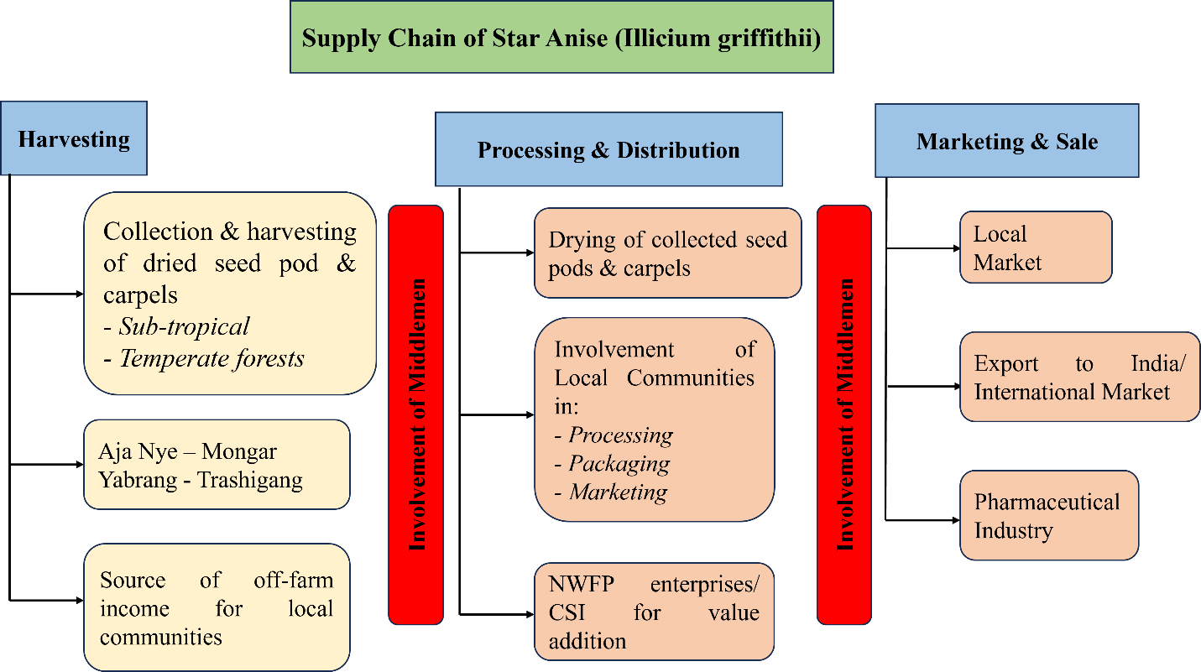
The Management of Bumdeling Wildlife Sanctuary will support the group through capacity-building programs. Until now, the group has primarily been engaged in collecting fruits and selling them in bulk to local buyers. With support from the Bhutan for Life project, BWS will assist the group in improving packaging, labeling, and processing the products into tea bags, as well as obtaining certification from BAFDA. These interventions will enable the group to access international, regional, and local markets. However, if the project does not support the packaging and branding initiative, the raw star anise will be supplied to the Bamdir Herbal Tea Processing Unit in Trashiyangtse, Bumdeling, for herbal tea production, subject to phytochemical analysis and approval by BAFDA, if feasible.

PART B: GROUP BY-LAWS

10. NWFP management & marketing group

10.1 Membership arrangement and resignation
The existing 19 households from three villages of Yarab, Thramo, and Thilling under Shelrimuhung gewog continue to manage the NWFP group as ‘Aja Illicium griffithii (Star Anise) Management Group.

New membership
- Fragmented family members opting to join the group shall be allowed upon payment of the equivalent amount of membership fees collected from the individual members since the initial inception of the group
- Gungtong or those households who do not join the group currently shall be allowed upon payment of an equivalent share of the fund accumulated in the group, including the membership fees collected from the individual members since the initial inception of the group

Withdrawal of members
- Group members willing to resign from the group shall be allowed. However, he/she shall have no right to claim any benefits, such as income generated from the sale of star anise and various contributions made to the CDF
- He/she shall have no access to resource utilization from the designated area
- He/she shall resign from the group only upon the clearing of outstanding fees, fines, and penalties
- Exceptional cases shall be considered for resignation from the group, such as migration/settlement to other places from these villages, which shall be entitled to their share of the total accumulated amount in the CDF

10.2 Responsibilities and rights of members
- All members should monitor and protect the Aja Illicium griffithii management area and inform the committee member if any illegal activities are found
- Group members should strictly follow the harvesting prescription as per the management plan during the harvesting season.
- Conduct patrolling of the NWFP area during the fruiting/harvesting season
- Group members shall collect seed pods as per the prescribed harvesting guidelines in the management plan
- Group members should cooperate with executive committee members in regards to implementation of the management plan
- All members agreed to collect the annual membership fee twice a year with Nu. 50.00 every six months by the executive committee members and deposited into the CDF account
- All group members shall have the right to decide on the utilization of CDF
- 2 meetings will be conducted in 2nd and 8th month of the Bhutanese calendar annually

11. Executive committee of the NWFP management and marketing group

11.1 Chairperson
Name: Chimi Gyeltshen
Responsibilities of Chairperson
- Administration work
- Coordinate meetings and activities
- Inform the members of the collection date of seed pods during the harvesting season
- Approving and issuing a collection permit to the members
- Settlement of disputes and conflicts among members
- Coordinate marketing and sale of collected seed pods to the NWFP dealers/buyers
- Coordinate in carrying out patrolling of the area during the harvesting season to curb illegal collection
- Impose fines and penalties if both group members and outsiders fail to comply with the management plan
- Reporting and presenting of annual progress to stakeholders
- Countersigning on the CDF account to withdraw the group fund
- Participate in training/workshops/study tour/meetings
11.2 Secretary
Name: Tashi Gyeltshen
Responsibilities of the Secretary:
- Officiate as Chairperson during his absence
- Keeping all the important records pertaining to the group management
- Maintain minutes of the meeting
- Issuing of a collection permit
- Assist the chairperson with the sale and marketing of the product
- Keep a record of sales and marketing of the product
- Countersigning on the CDF account to withdraw the group fund
- Participate in training/workshops/study tour/meetings

11.3 Treasurer
Name: Karma Wangdi
Responsibilities of Treasurer:
- Maintain cash transaction records, such as annual group fund generation through the sale of seed pods and expenditure incurred
- Collects annual membership fees and deposits to the CDF account
- Collect and deposit fees, compensation, fines & penalties, and the revenue accumulated from royalties levied from the members through the issuance of permits for domestic purposes
- Process for withdrawal of cash from the bank during an emergency and loaning to group members
- Prepare and present financial status to chairperson and group members during meetings
- Countersigning on the CDF account to withdraw the group fund
- Participate in training/workshops/study tour/meetings

12. Tenure of committee members
The committee members, unanimously elected by the group members, will serve a term of five years, after which the group shall conduct a re-election for the executive committee.

13. Incentives to the committee members
The seed pods collected by all the group members should be well dried and handed over to the executive committee members for marketing and sale during every harvesting season. Similarly, executive committee members shall explore potential markets within and outside Dzongkhags.
- To compensate for the expenditure incurred, the group members have decided to pay an annual incentive of Nu. 1000.00 to Chairperson, Nu. 800.00 each to the Secretary and Treasurer from the CDF
- The executive committee members shall be paid Nu. 300.00 per day in attending the training/workshops/study tour/meetings from the group CDF as the government entitlement of Nu. 215.00 per day is not enough to meet the travel expenses incurred.

14. Source for the generation of the group fund

Membership registration fees/annual contribution
- A sum of Nu. 100.00 (One hundred) only would be levied from all the members as an annual membership fee. However, the membership fee shall be collected twice a year with Nu. 50.00 per household on each occasion
- The amount shall be collected during the annual general meeting, and the same shall be deposited in the CDF account maintained with BDBL
- The group decided to issue a collection permit with a fee of Nu. 50.00 each for the members during the harvesting season in addition to the permit fees of Nu. 10.00 each

14.2 Collection from the sale of proceeds
- The major revenue shall also be generated from the sales of proceeds.

15. Group fund management and utilization
- The income generated from the sale of seed pods, annual membership fees, royalty levied from the collection permit within group members for domestic consumption, and fines & penalties will be deposited in the CDF account, which shall then be operated jointly by three executive committee members for smooth functioning and better transparency
- Group members shall avail a loan from the CDF with an interest rate of 6% per annum with a maximum duration of 1 year. However, the loan should be approved based on the general consensus or 2/3rd of the majority of the group members, not exceeding 50% of the total accumulated CDF. The loan amount should be paid along with interest within the stipulated period, and failing which he/she should bear the penalties of 24% per annum as per financial rules
- CDF shall utilize during emergencies in the locality and for other community development activities to benefit all the group members
- All group members should agree and endorse the utilization of CDF for any purposes

16. Conflict management
- If any conflicts or disputes arise in relation to resource sharing and access, within group members shall be dealt with and solved by executive committee members
- If the case is beyond the scope of executive committee members, the matter shall be forwarded to the gewog administration and other relevant stakeholders
- In case dispute or conflict that cannot be solved or settled by the gewog administration, it shall be further forwarded either to the Dzongkhag administration or the court, based on the degree of the case, for further action
- In case there is a conflict between the NWFP group members and outsiders pertaining to illegal activities, the case shall be forwarded to the Park Range Office in Serzhong

17. Meeting and Purpose

17.1 Committee meeting:
The committee meeting shall be called as and when required.

17.2 General Meeting
The general meeting shall be conducted twice on a half-yearly basis. This is generally to discuss the activities, the group’s achievements, planning, and to resolve various issues.

18. Penalties
- If any group members or outsiders are found collecting the star anise without the approval or collection shall be penalized. 200.00 per kg for wet seed pods and Nu. 400.00 per kg for dry seed pods
- A fine of Nu. 300.00 per incident shall be collected if any group members fail to attend meetings
- A fine of Nu. 300.00 per incidence shall be collected even if the group members have not conducted the 2 general meetings as per the schedule
- Similarly, if any group members are found absent during the star anise harvesting season, a fine of Nu. 500.00 per day shall be penalized as a penalty

19. Roles and authority of the Department
The following are the roles and authority bestowed on Bumdeling Wildlife Sanctuary (BWS) during the entire management plan period.
- BWS, in collaboration with the Forest Resources Planning and Management Division (FRPMD), shall provide technical support and guidance during the implementation of any activities on Star Anise management
- BWS shall provide support for the amendment and review of the management plan if needed for any changes
- Inspection, monitoring, and reviews of the activities based on the management plan shall be conducted from time to time
- Take action on any illegal activities based on the Forest and Nature Conservation Rules and Regulations of Bhutan, 2023
- Except for star anise seed pod collection, the department shall exercise the power to manage, protect, and utilize other natural resources in the designated area
- Department of Forest and Park Services and BWS management shall have the right to cancel the certificate of Aja I.griffithii management plan if the group fails to perform and implement as per the approved management plan
- BWS shall facilitate the delivery of forestry services based on the Forest and Nature Conservation Act of Bhutan 2023, and its rules & regulations 2023

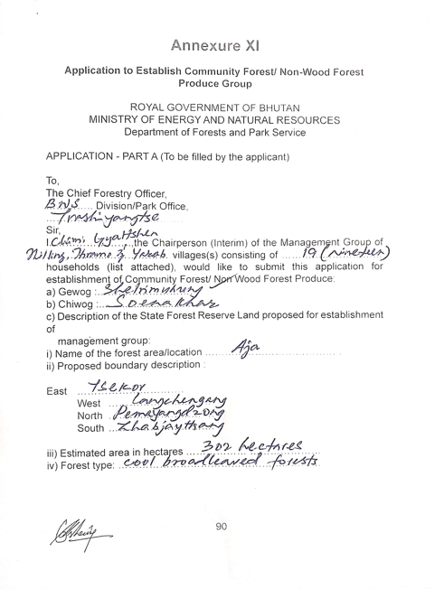
ANNEXURE I: Application

